Sally Hillman - Celebrating Champagne
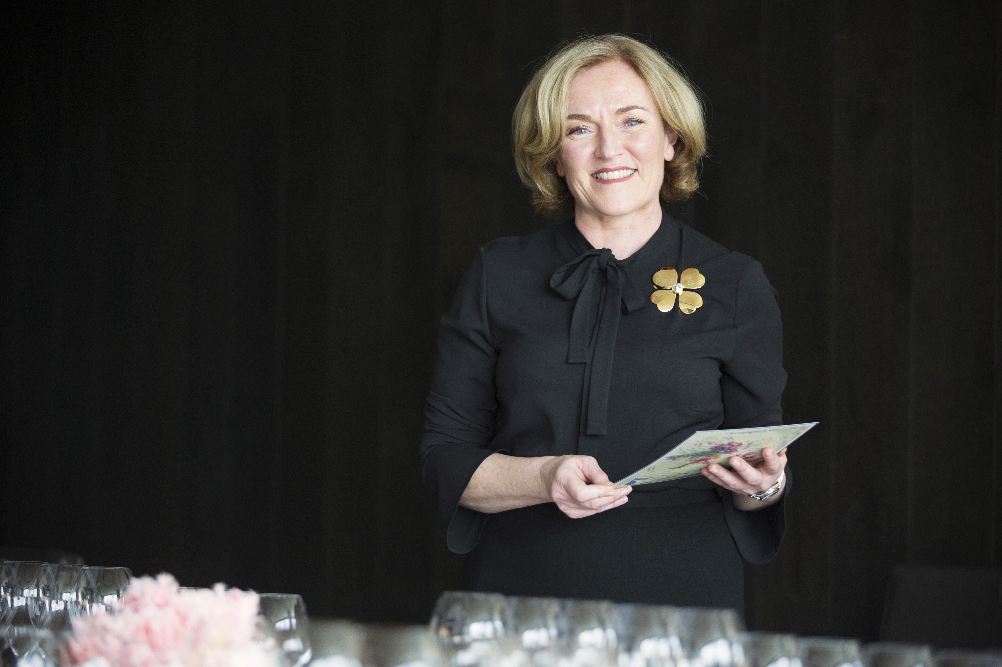
Champagne was an important element of family celebrations while Sally Hillman was growing up. This early appreciation and love of champagne became a life-long passion and led Sally on a mission to share champagne's magic and sophistication with others. Combined with the fact that Sally shares her birthday with Saint Vincent, the patron saint of winegrowers, whose feast day is taken very seriously in Champagne, it is easy to see that champagne was always going to feature in Sally’s destiny.
Based in Melbourne, and with a global presence, Sally specialises in the flourishing world of grower-producer champagnes, otherwise known as récoltant-manipulant champagnes. These artisanal champagnes are produced by the grape growers themselves, from their own grapes. Houses are family-owned and operated, and vine holdings are modest, passed down from generation to generation. They aim to craft champagnes from sustainable farming practices and natural, low-intervention processes with minimal added sugar so that each cuvée evokes a strong sense of place (terroir).
The Sally Hillman company specialises in creating memorable and bespoke food and champagne pairing experiences for corporate clients and private guests. The Sally Hillman company also offers corporate gifting and special occasion services throughout the year.

In her online store, 'Le Shop,' Sally offers over 28+ Houses and 115+ cuvées available for purchase and direct shipping nationwide. Be tempted by a range of luxurious and specialised accessories, including handmade French glassware by Lehmann Glass, Sally Hillman’s signature Champagne cartography, and much more.

Sally is not only the founder of her company but also a renowned champagne educator and presenter. In 2018, she was selected as a finalist in the Vin de Champagne Awards, an acknowledgment bestowed by the Australian Bureau du Champagne for her exceptional skills and unwavering commitment.

Every year, Sally hosts the highly-rated Tour de Champagne, an intimate, multi-day Champagne tour offering exclusive access and unique insight into world-class Estates and prestigious grower-producers.
With Sally as your guide, you’ll learn why champagne is a wine for all seasons and become an advocate for Celebrating Champagne at every opportunity!
www.sallyhillman.com.au

